Citation note:
We used ChatGPT to help debug and ask questions regarding pytorch documentation / syntax. Other citations are in the readme below and some are mentioned in the comments of the .ipynb notebook itself.

Fashion_MNIST practical
Applying the architecture from LeNet-5 CNN (LeCun et .al., 1998) for Classification on the Fashion-MNIST dataset by Zalando (2014)

See http://vision.stanford.edu/cs598_spring07/papers/Lecun98.pdf & https://github.com/zalandoresearch/fashion-mnist

Content Overview
This project includes a Jupyter Notebook file which creates a training and tuning regime for finding a champion model. The functions 'tune_hyperparameters', 'train_epoch', 'evaluate', 'plot_accuracies' are generalized to be applied to models with different regularization techniques.

Dependencies
All dependencies are imported within the markdown file. Simply run the file to import correct packages. Please use Python 3.10+

Data Upload
It is difficult to persist data files in Google Colab. As such, we decided to use wget so that we can retrieve the dataset easily whenever we run the notebook. After importing the dataset, we unzipped and read the idx files to store into our train and test sets and to convert these into tensors. We then split our train set into train and validation by setting the validation size to 5000 and using a random split.

Key Functions

'train_epoch'
The 'train_epoch' function trains and updates the parameters of the model for one epoch. It performs one forward pass and backpropagation to update the weights using the specified optimizer (SGD or Adam is what we use in this project). The function returns the loss and accuracy of the training epoch

'evaluate'
The 'evaluate' function evaluates the performance of a model. It uses torch.no_grad() to disable gradient calculation after training. This function then gets predictions from the images put into the model and calculates loss (using the loss function used for the 'criterion' argument) between predictions and true labels. Next, it calculates the epoch loss as an average of loss across all batches, and returns this average in addition to the epoch accuracy.

'plot_accuracies'
The 'plot_accuracies' function is used to plot the train and test accuracies as a function of training epoch. This function is called once within 'tune_hyperparameters' in order to plot these values for the champion model determined by hyperparameter tuning

'tune_hyperparameters'
The 'tune_hyperparameters' function performs a brute-force grid-search through all possible hyperparameter combinations in order to find a champion model with the optimal hyperparameters. The function trains a model for each combination for a default of 'num_epochs' = 10. The following are default arguments for hyperparameters:

- batch_sizes=[32, 64, 128]
- learning_rates=[0.1, 0.01, 0.001]
- optimizers=['SGD', 'Adam']

These default values leave us with 18 tuning iterations by default. It is recommended to connect to a GPU for this computationally intensive task. This function also has arguments 'dropout_rates' and 'weight_decay_weights' which default to 'None' but can take a list of floats to add to the hyperparameter grid-search. Importantly this function handles the deactivation of dropout for model evaluation. This function uses the above three functions defined in order to track a champion (optimal) model based on validation accuracy. The function creates an accuracy plot for the best model and returns a champion model along with champion parameters and the highest training accuracy. To call the function on a model without dropout (i.e. base model, batch normalization), you should create a 'partial' of the model so that 'tune_hyperparameters' can accept the model input

from functools import partial

LeNet5_no_dropout = partial(LeNet5)

best_model, best_params, lenet_train_acc = tune_hyperparameters(LeNet5_no_dropout, train_loader, val_loader, test_loader, device, title='Accuracy vs. Epochs for non-regularized model')

Calling a model with dropout can be done the following way:

def create_le_net5_dropout(dropout_rate):

return LeNet5_Dropout(dropout_rate)

dropout_rates = [0.2, 0.3, 0.4, 0.5]

best_model_dropout, best_params_dropout, dropout_train_acc = tune_hyperparameters(lambda dropout_rate: create_le_net5_dropout(dropout_rate), train_loader, val_loader, test_loader, device, dropout_rates=dropout_rates, title='Accuracy vs. Epochs for model with dropout')

How to Train and Test each Setting
In order to run our cells for training and evaluating model performance at different settings, it is required that all previous cells are run. For convenience, we have set the first comment to each critical cell to say “# MUST RUN” so that anyone accessing our notebook will know what cells are needed for any train/test cell.

From here, we have numbered the different settings from 1-4 corresponding to different versions of the LeNet-5 Model. As long as the “# MUST RUN” cells have been run, any and all of these cells can run independently. Simply run the cell for the desired setting and the model will be trained and then evaluated on the best model discovered during training. The weights, training accuracy, and test accuracy will all be automatically saved to variables as set up in each cell.

Results

Base Model (No Regularization)
Final Test Accuracy: 89.05

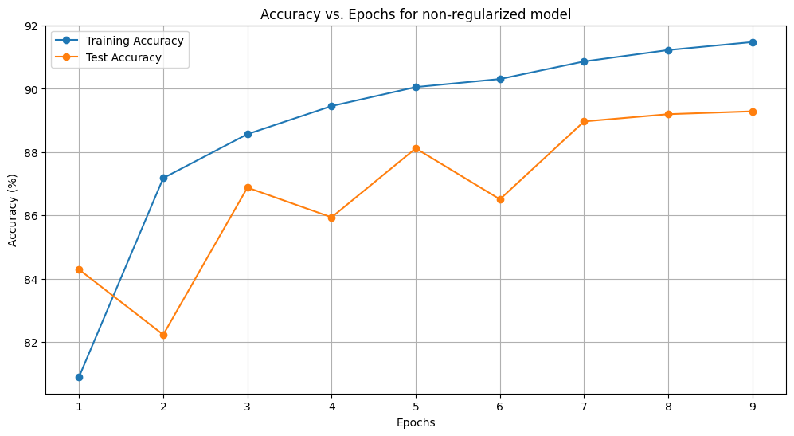

Dropout Regularization
Final Test Accuracy: 89.92

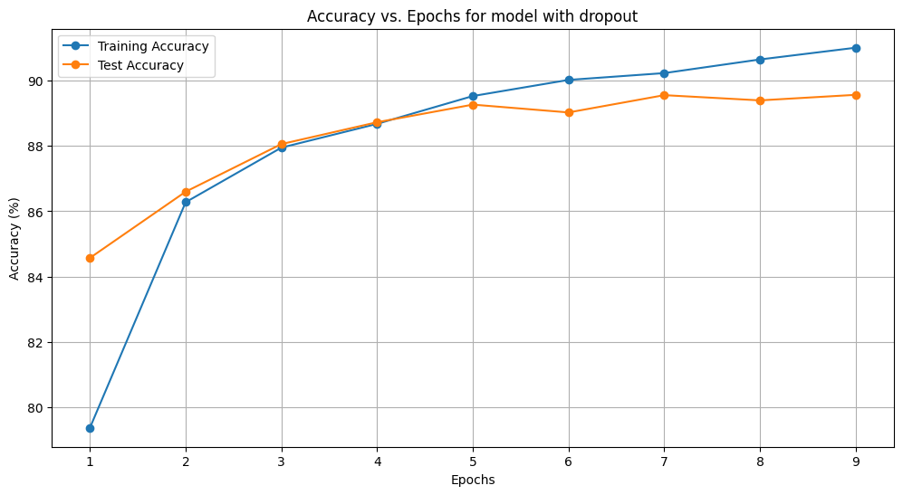

Batch Normalization
Final Test Accuracy: 89.72

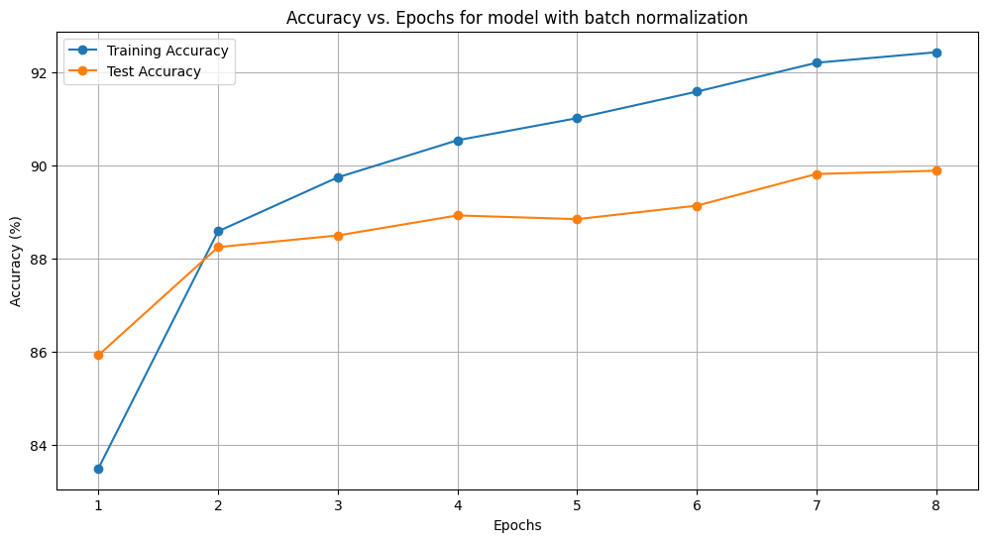

Weight Decay (l2 regularization)
Final Test Accuracy: 89.40

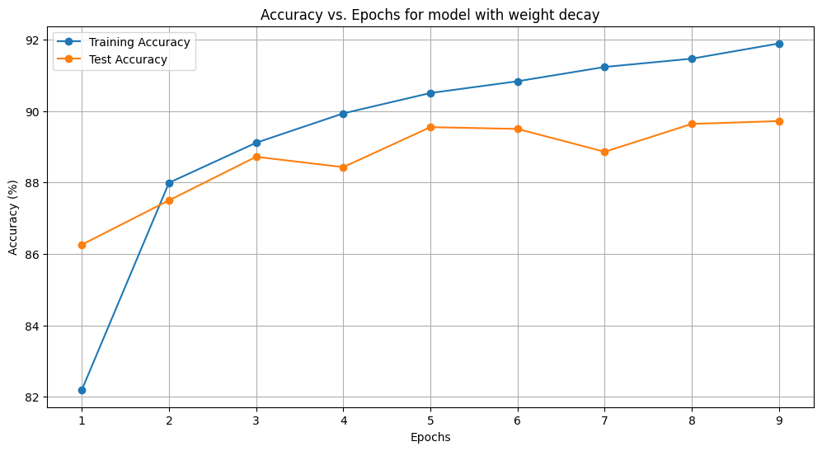

Final Results

